Database Laboratory work 2

Prerequisites: SQL Manager 2017, Device with Internet Connection

Objectives: Learn to create management & maintenance plans, file BLI size allocation. Defining logical and physical folders, scheduling.

### Student: Corman Daniel

### Grupa: FAF 191

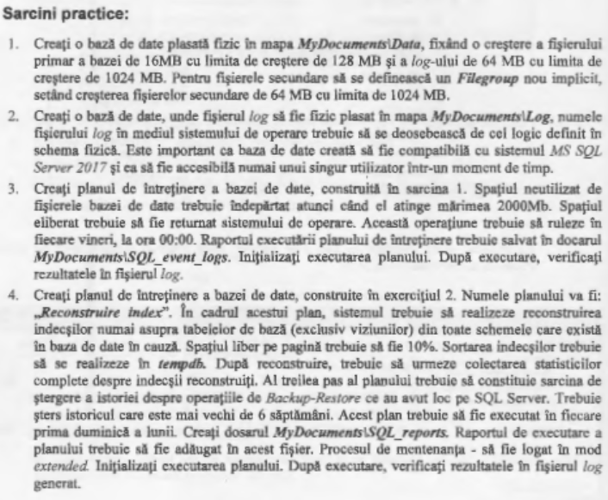

# Implimentation

Tasks:

Task 1:

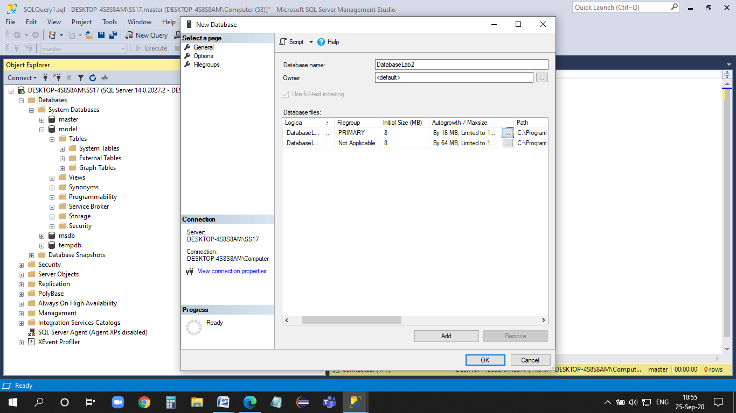

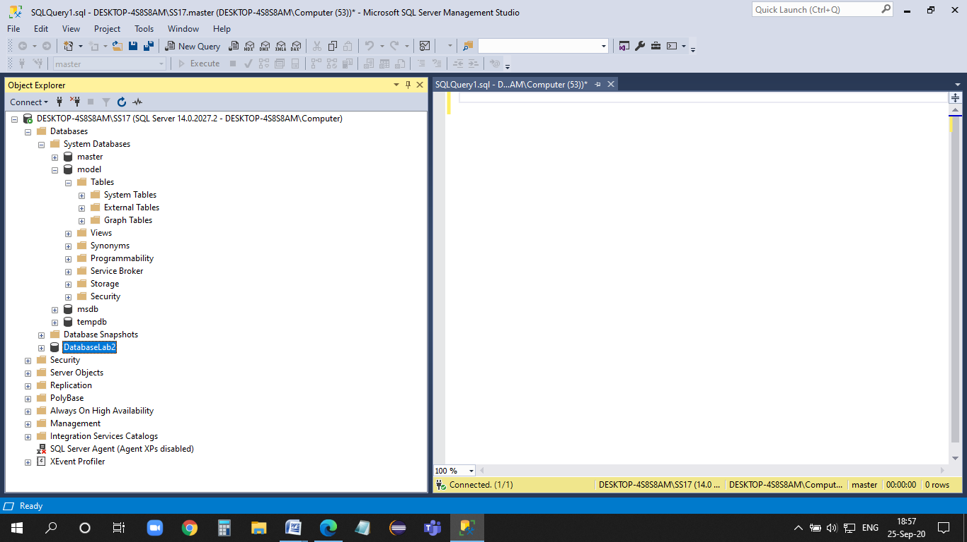

Task 2:

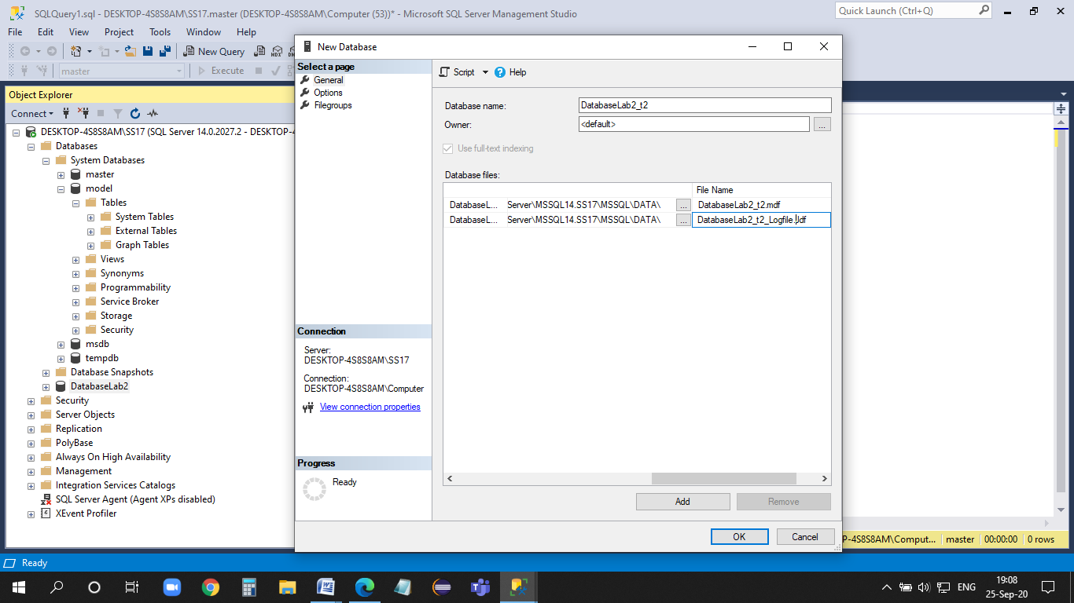

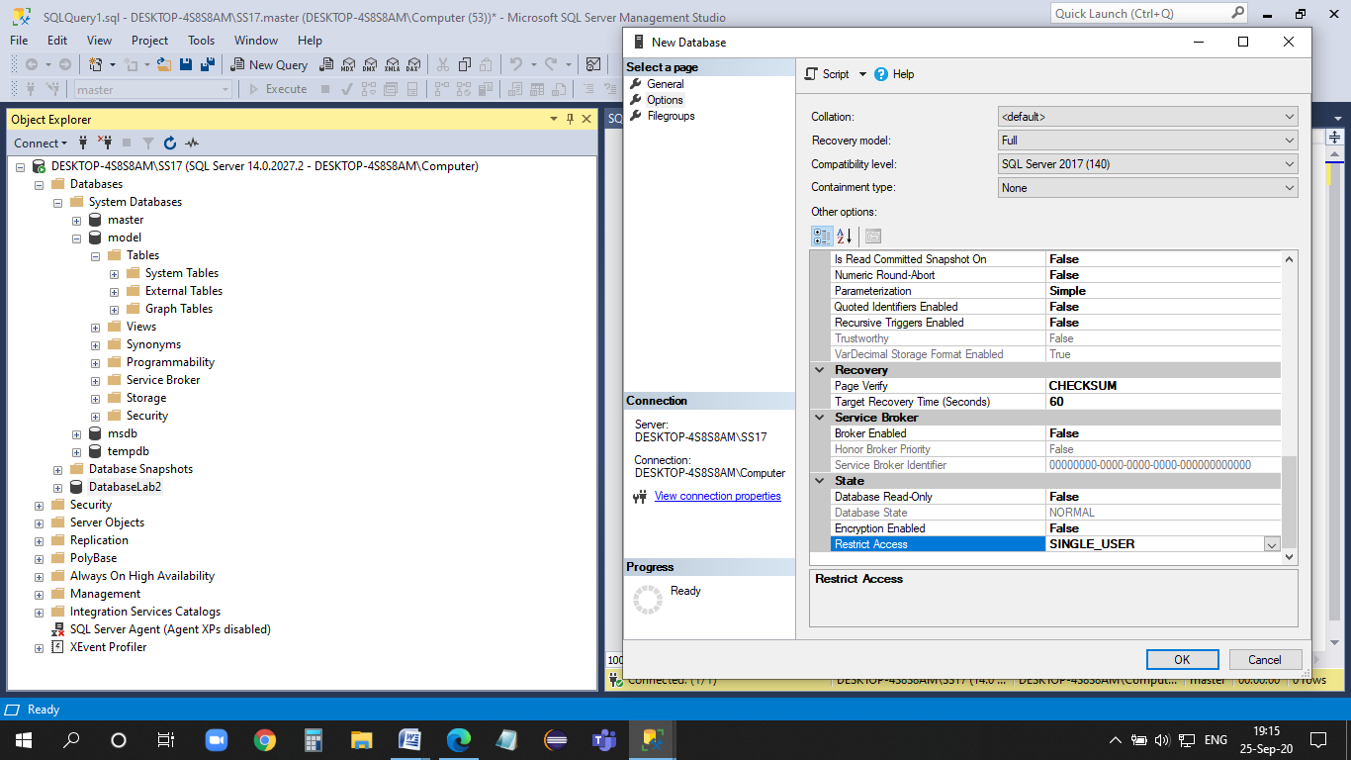

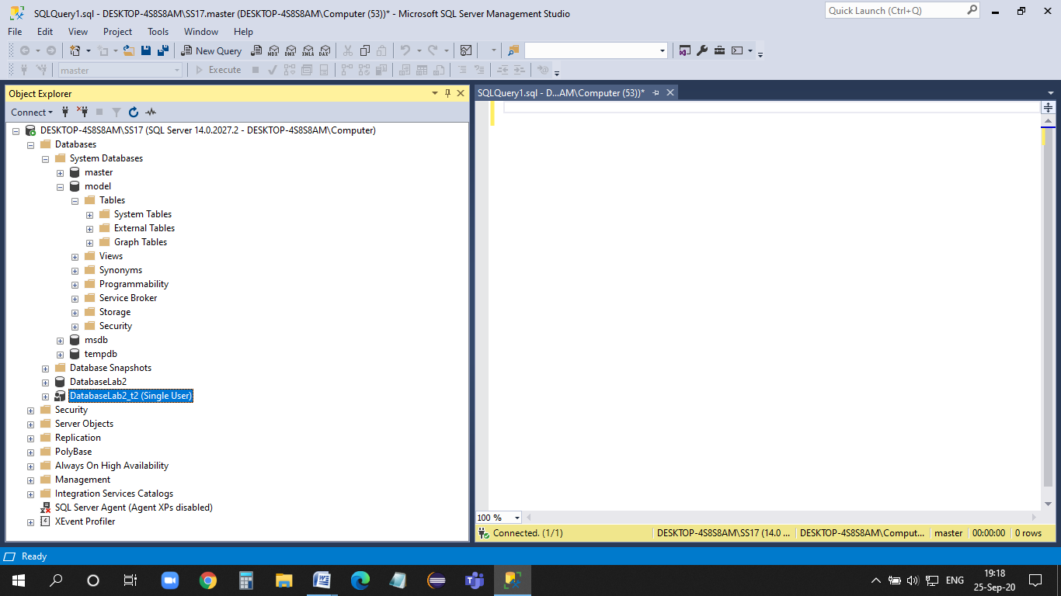

Task 3

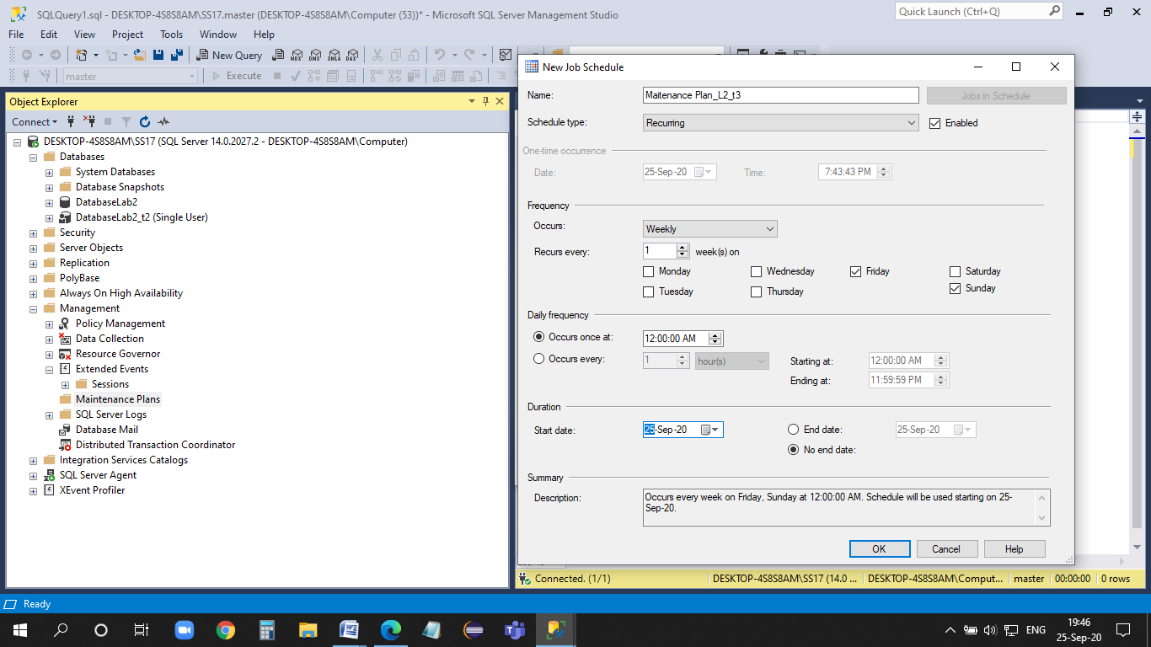

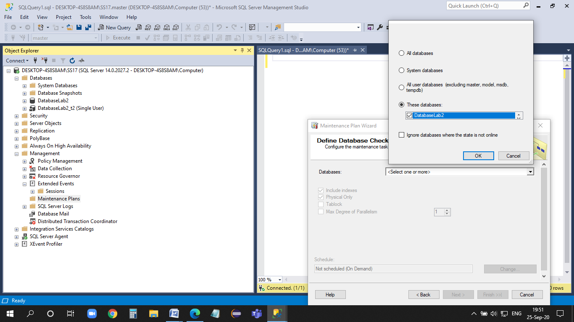

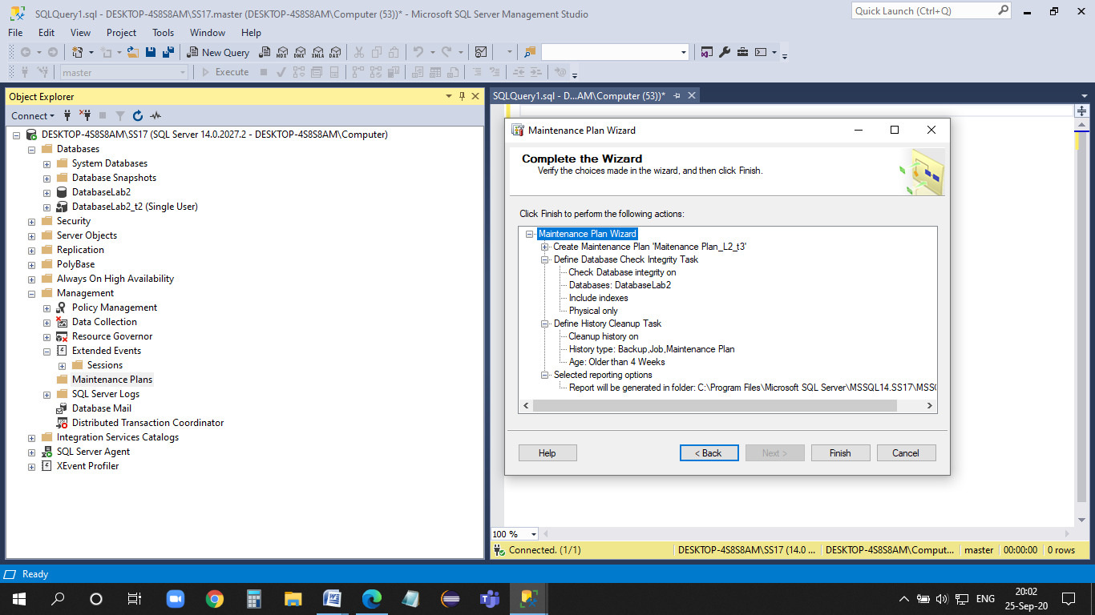

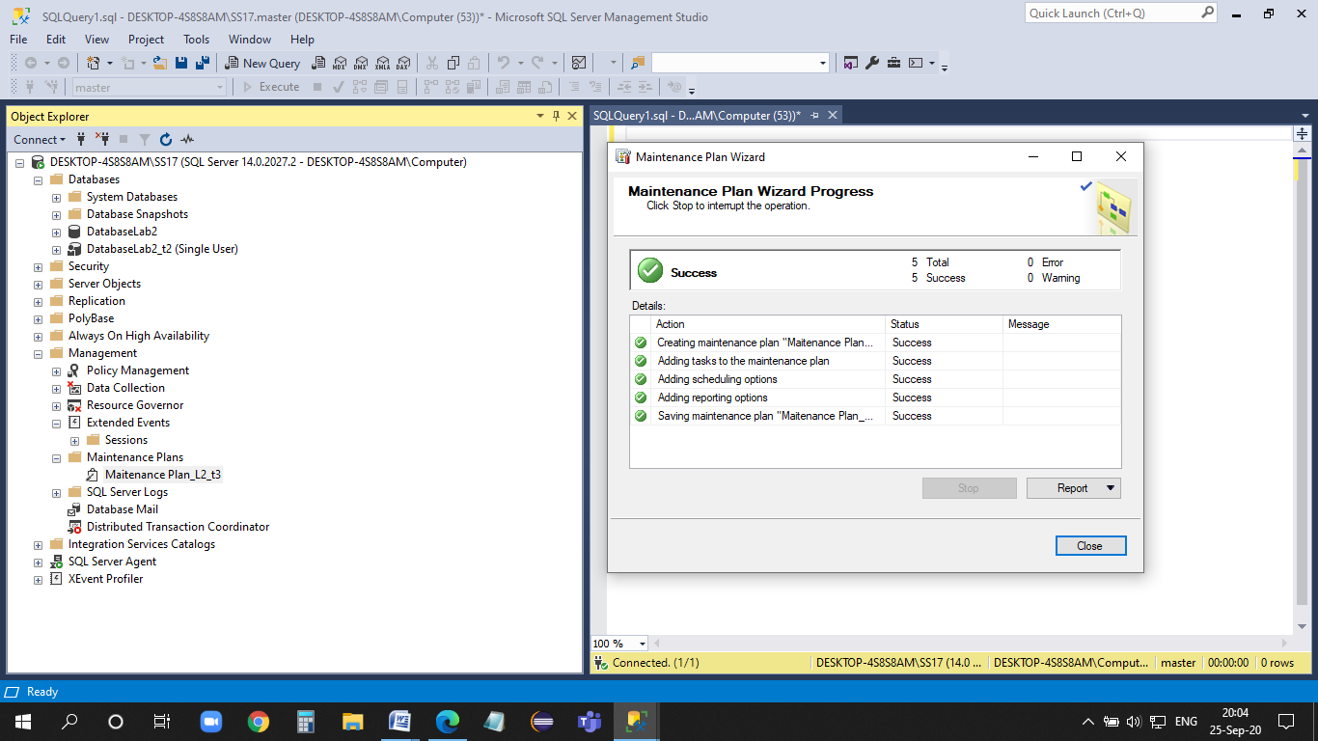

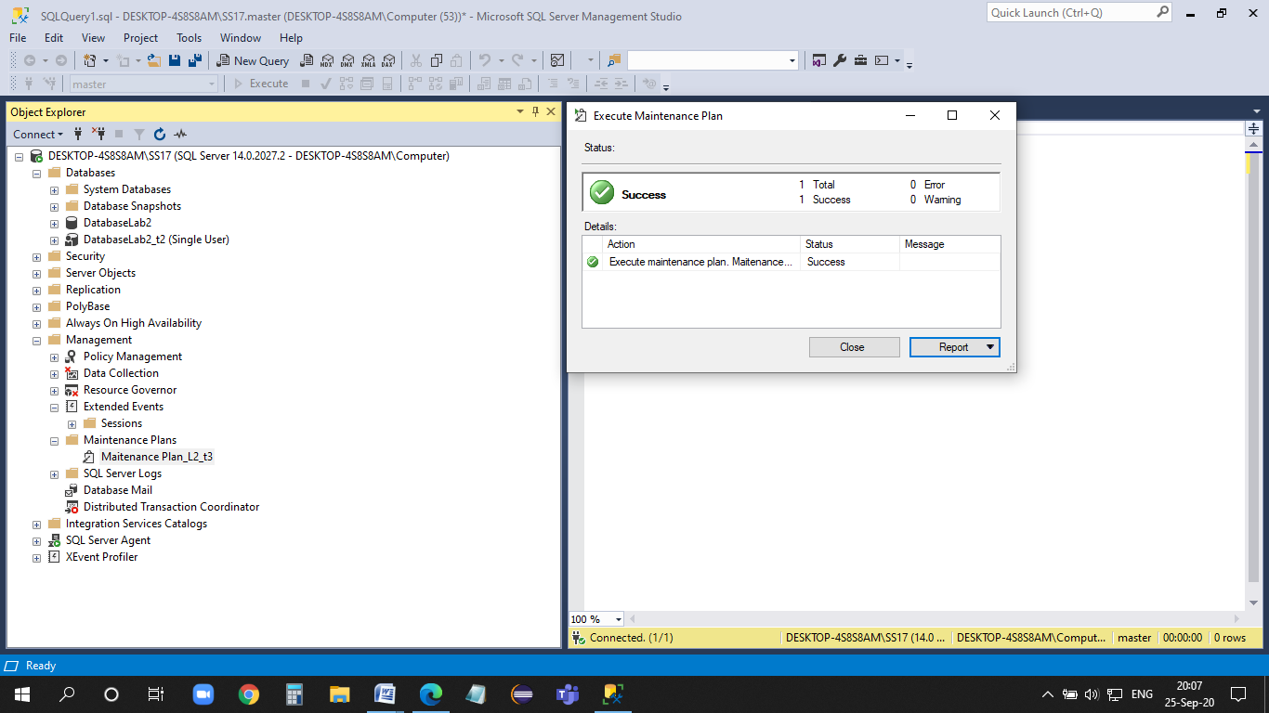

Task 4:

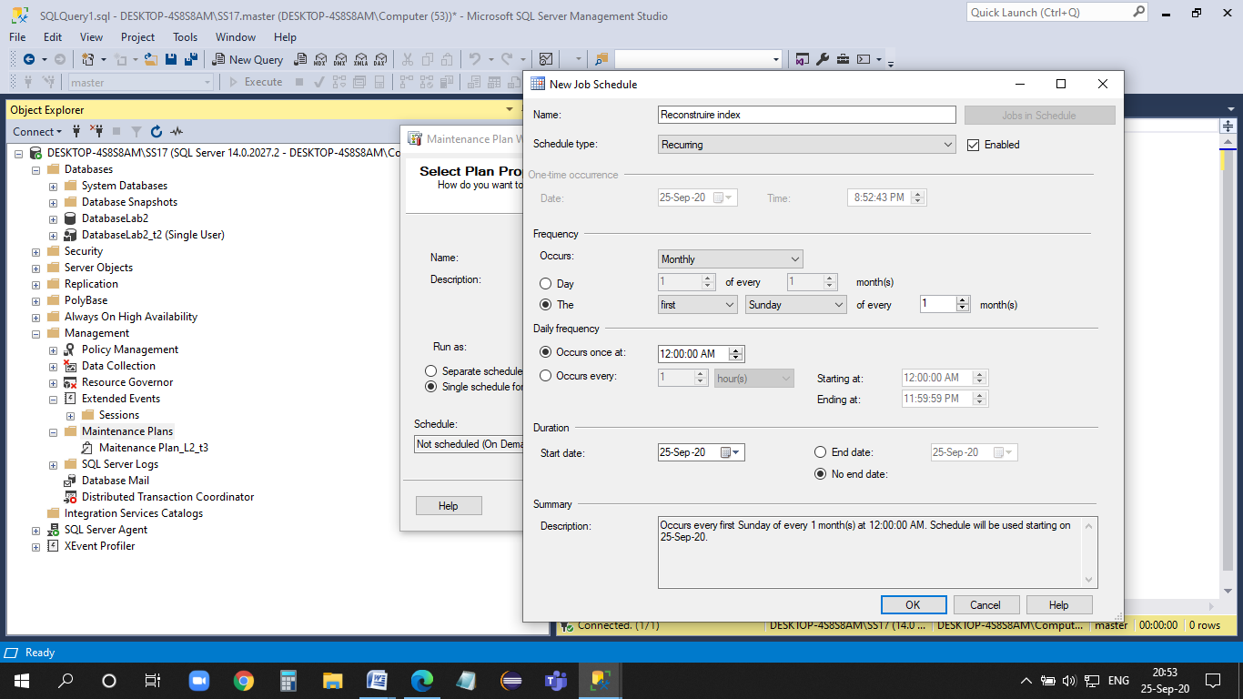

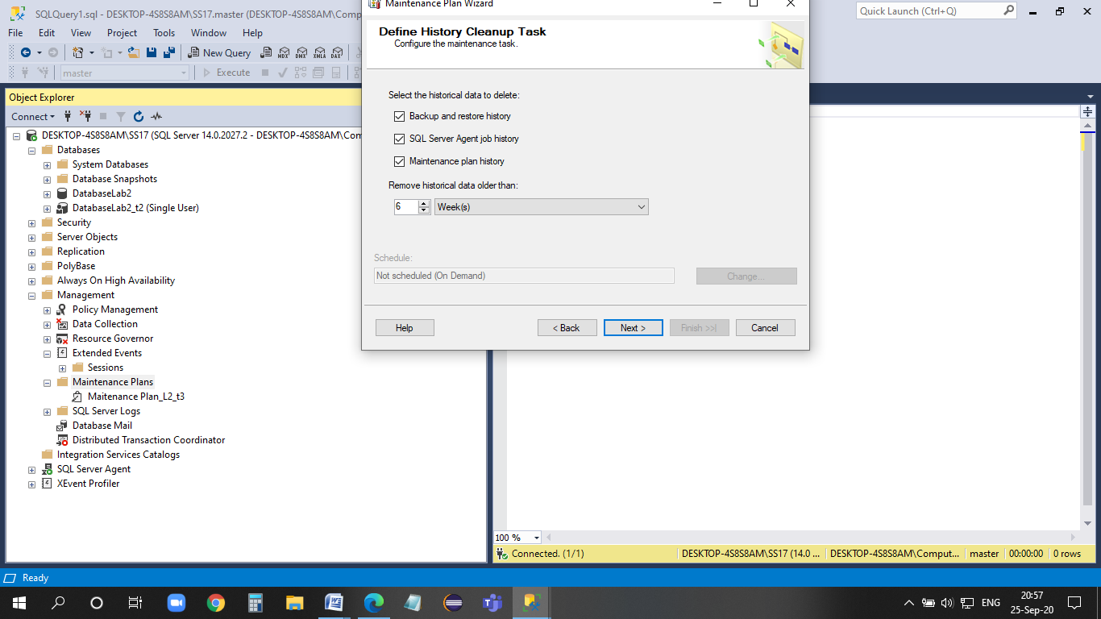

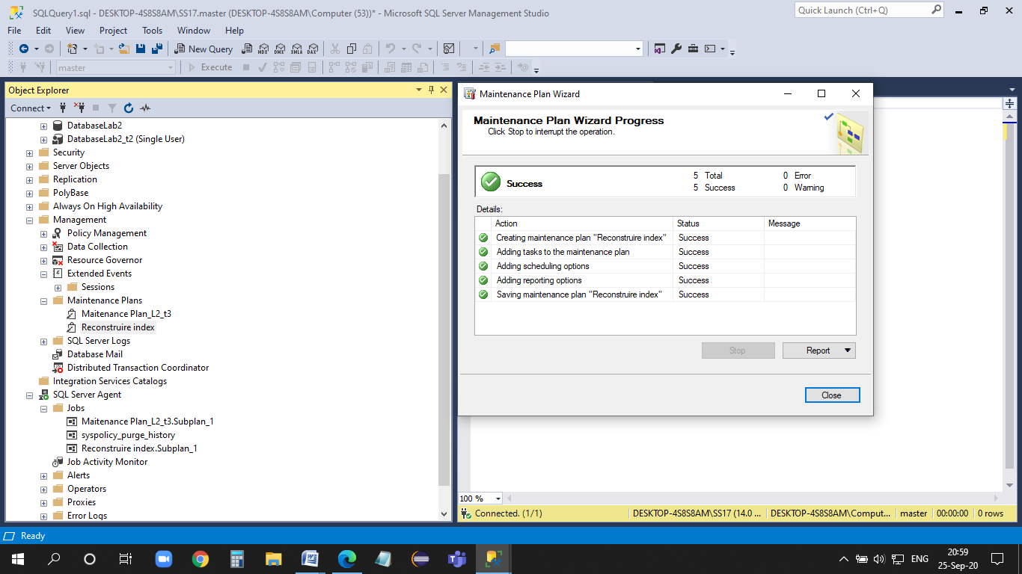

## Conclusion

During this laboratory work we have learned how to set up maintenance plans & manage a database, also how to allocate memory size for BLI files , how to manage folders and how to set up a schedule, tasks that are basic and very important during learning databases.